Abstract Template for the 11th International Conference on

Plasma Medicine (Times New Roman 16, bold, centered)

Name Surname¹, Name Surname² (Times New Roman 12, normal, centered)
¹Institution, Address, Country
²Institution, Address, Country
E-mail: corresponding_author@email.com (Times New Roman 11, normal, centered)

Abstracts must be in English and should report new previously unpublished work. The total length, including figures and all references, is limited to one A4 format page (all types of contributions - plenary, invited, contributed oral lectures as well as for posters). Please follow the requested format of the abstract template. The abstracts that will not conform the format will be rejected. Abstracts have to be submitted via the conference website. The submitted abstract must be a PDF file.
※ Deadline for abstract submission is December 25th 2025.
All submitted abstracts will be refereed by the International Scientific Committee (ISPM Board). Based on their scientific quality and relevance to the conference topics, the abstract will be either accepted for publication in the Book of Abstracts or rejected.
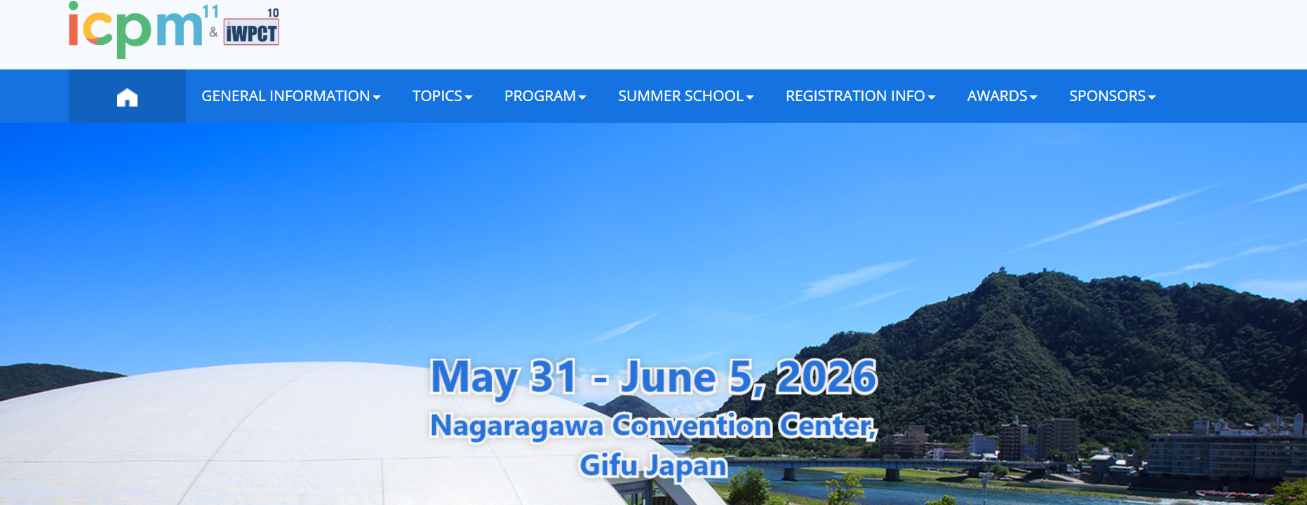
Fig. 1 Plasma Medicine 2026

General requirements for the format of the abstract
The abstract should be typewritten for A4 format paper, maximum one page for all contributions.
- Margins: Top: 3 cm, Bottom: 2 cm; Left and Right: 2 cm. Please respect the margins!
- Paragraphs: Single line spacing. A single line left empty between two consecutive paragraphs.
- Font: Times New Roman. Title: 16 pt, Bold, centered. Authors names: 12 pt, Normal, centered. Affiliations: 11pt, centered. E-mail: 11 pt, Normal, centered. Main text: 12 pt, justified left and right.
- Figures and Photos: Abstract may include figures and photographs. A caption should be attached to each figure. Caption style: Fig. 1. Your text.
- Acknowledgement: Times New Roman, 12 pt. After the main text and before the references (separated by empty lines).
- Citations: Times New Roman, 12 pt. Cite references using square brackets [1-4]. Examples of the format to be used are given below.

This work was supported by National Grant no. ….

References
[1] A. Author, B. Author, and C. Author, Journal, Volume, Page (Year).
[2] A. Author, Title of Book, Publisher, City (Year).
[3] A. Author and B. Author, Conference, Dates, City, Country, Page (Year).

